**ConveyLinx MDR Replacement Procedure:**

**Software Required:**

* EasyRoll V4.0
* Firmware version 5.02 – provided in email from USS.

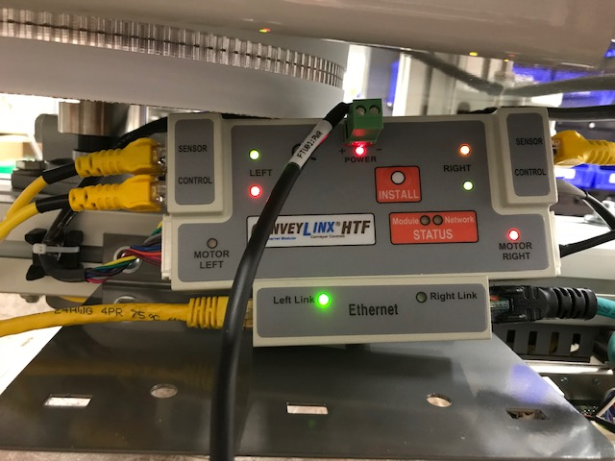

Note! As shown above Red LED’s do not indicate card failure!

**STATUS INDICATORS**

ConveyLinx module status is indicated by several LED’s. All LED’s with the exception of the Ethernet Link and Activity LEDs are multi-colored and context sensitive. The following chart indicates the various meanings of all LED indicators. Please refer to ERSC Module Hardware Overview on page 17 of the user’s guide for the item number locations on the module. By definition ‘Blinking’ is approximately ½ second on/off cycle and ‘Flashing’ is approximately ¼ second on/off cycle.

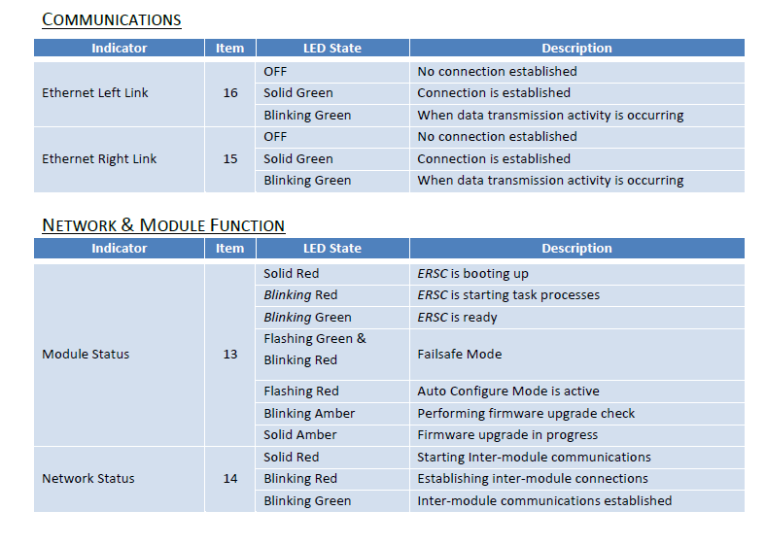

Procedure

1. Shut down power to system. Lock Out and Tag Out power.
2. Remove all cables from the card making note of their location – take a photo if necessary.
3. Replace ConveyLinx MDR card and reconnect all cables except ethernet.
4. Remove Lock Out and power up system.
5. Using Cat 5 cable connect laptop/PC to the ConveyLinx card in either the right or left ethernet port .
6. Change the IP settings for the ethernet port in your laptop to match the Network IP scheme of ConveyLinx card. The card’s default IP is: 192.168.202.20 so set laptop to 192.168.202.XXX where the last triplet is a number between 100 and 255. Change the Laptop/PC’s Subnet to 255.255.255.0
7. On your laptop/PC, ‘Right-Click’ on the EasyRoll 4.0 desktop icon and select **Run As Administrator**.
8. Once software is running, establish a network connection between the ConveyLinx card and your laptop/PC by hitting **Refresh** button in EasyRoll software.
9. Click on **Advanced Dialog** box and click on **Upgrade** tab to upgrade the firmware with the latest version using ConveyLinx_5.02.bin file sent to you. If installed version is already 5.02, proceed to next step. Important: Be sure file has completely installed. This isn’t immediately apparent so wait 60 seconds even if installation says that it is complete.
10. Click on **Advanced Dialog** box and click on **Network Services** tab and click on **Discover** under **Show devices on Subnet** to change the Network IP settings of the selected node if needed. As per Intelligrated/Amazon the IP address settings for new OSLs will be 1) IP Address: 11.200.1.20 2) Subnet mask: 255.255.252.0 and Default gateway: 11.200.1.100
11. To use the ConveyLinx card in PLC I/O mode, click on **Advanced Dialog** box and click on the **Connections** tab. Make the settings as shown below and click on **Apply**.

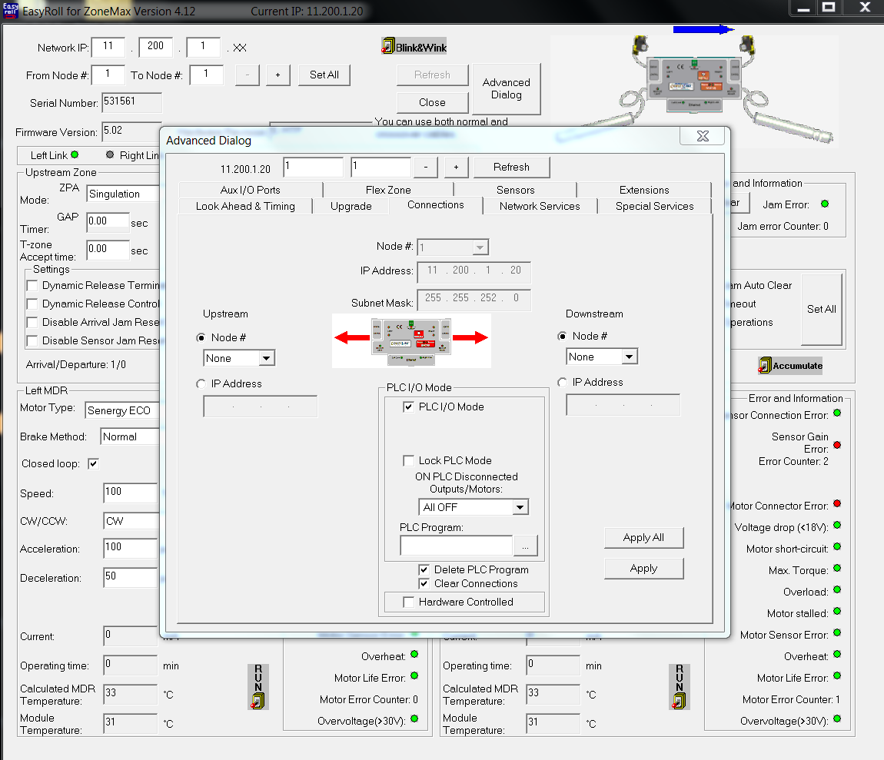

1. For changes to take effect, power system off. Wait at least 30 seconds and turn the system back on.
2. Go to HMI maintenance screen and verify that all photo eyes and prox. sensors are working.
3. Verify pulse roller runs both CW and CCW.
4. Verify FTU rotates both CW and CCW.
5. Exit Maintenance Mode and return system back in service.